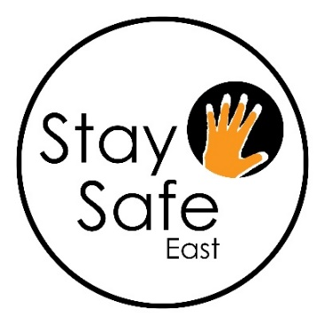
Stay Safe East
Supporting disabled survivors
is seeking an exceptional person to join us as our new
Finance and Operations Manager
We’re writing our next chapter. Be part of it!
Salary: £ 31,000 per annum pro-rata for 28 hours per week.

Stay Safe East is a unique organisation: we are one of only two funded Deaf or Disabled People’s Organisations (DDPO) in England and Wales working on Domestic Abuse and the only specialist DDPO working across all areas of abuse (domestic and sexual violence, hate crime, harassment and institutional abuse).
The Finance and Operations Manager is a member of Stay Safe East’s Management Team (MT) and oversees the day to day functions of Stay Safe East’s operations under the direction of the CEO and with the help of the Administrator. The post holder will be responsible for all Stay Safe East’s administrative and financial functions including:
• Operational support to the CEO and Management Leads
• Day-to-day financial management
• HR and Health & Safety management
• Office and facilities management
The successful candidate will have:
- A minimum of 3 years related experience of managing financial and human resources, health and safety and of administration oversight
- Demonstrable experience of day-to-day financial management; including bookkeeping, budgets, processing invoices and producing financial reports
- Experience of advising on HR and Health and Safety policies and procedures and in depth knowledge of relevant legislation
- A good knowledge of the charity sector and charitable funding
- An ability to work with colleagues accessibly and sensitively
- Excellent communication skills both verbally and in writing
- A commitment to Stay Safe East’s work and ethos
We particularly welcome applications from disabled people who reflect the diversity of London’s communities of faith, sexuality, culture, ethnicity and age.
Closing date: June 30th 2021, 5pm. Interviews will be on July 8th 2021.
Please note we do not accept CVs.
To apply, please download the job pack and an application form from our website at www.staysafe-east.org.uk or from Charity Jobs | Charityjob.co.uk or https://jobs.thirdsector.co.uk/jobs/
For an accessible Word format of the pack or other formats: please e-mail recruitment@staysafe-east.org.uk or ring/text Jo 07908 092 132 or Ioana on 07865 340 122

