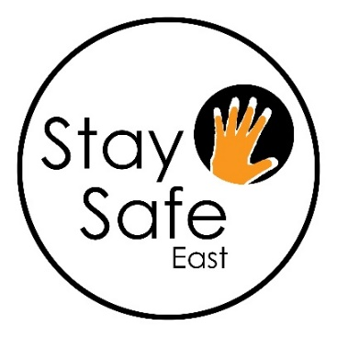

**Stay Safe East**

***Supporting disabled survivors***

**is seeking an exceptional person to join us as our new**

**Operations Manager**

**We’re writing our next chapter. Be part of it!**

**Salary: £ 33,170 per annum pro-rata for 17.5 hours per week.**

**Stay Safe East** is looking for an Operations Manager who will be responsible for managing the Charity’s operational and administrative functions, with the support of our administrator, support the CEO on HR and governance matters, and ensure compliance with GDPR and health and safety.

Stay Safe East is run by disabled people and supports disabled survivors of domestic and sexual violence, hate crime and other forms of abuse.

**The successful candidate will have:**

* Demonstrable experience of managing the operations of a charity, small business or department within a larger organisation, including administration, GDPR and Health and Safety
* Understanding of the requirements of the Charity Commission and Charity Law
* Knowledge of HR practice (we have support form an HR specialist)
* An ability to work with colleagues accessibly and sensitively
* A commitment to Stay Safe East’s work and ethos

**We particularly welcome applications from disabled people who reflect the diversity of London’s communities of faith, sexuality, culture, ethnicity and age.**

**To apply, please complete the attached application form and monitoring form, and return them no later than Monday January 30th at 12 noon** by e-mail to: [admin@staysafe-east.org.uk](mailto:admin@staysafe-east.org.uk)

Please head your e-mail **Operations Manager Application**

**Important: Please ensure you return the forms as typed word document in 16 point, not as a PDF or handwritten document; this is so all forms are accessible to members of the interview panel.**

**or ring/text Charlotte 07828 608 342 or Ioana on 07477 617 461

**Closing date for applications: January 30th 2023 at 12 noon**

Interviews: February 2nd and 3rd 2023. The interview panel will be the CEO and a Board member.